**PIP2001 Capstone Project**

**Review-2**

# Customer Support Chatbot With ML

**Batch Number: 168**

|  |  |
| --- | --- |
| **Roll Number** | **Student Name** |
| **20211CSE0354** | **Naveen Kumar M** |
| **20211CSE0369** | **Mahmadkaip R S** |
| **20211CSE0383** | **Mohan S G** |
| **20221LCS0013** | **Madhu K** |

**Name of the Program: CSE**

**Name of the HoD: Dr.Asif Mohammed**

**Under the Supervision of,**

**Mr Asad Mohammed Khan Assistant Professor**

**School of Computer Science and Engineering**

**Presidency University**

**Name of the Program Project Coordinator: Mr.Amarnath JL/Dr.Jayanthi K**

**Name of the School Project Coordinators: Dr. Sampath A K / Dr. Abdul Khadar A / Mr. Md Ziaur Rahman**

* In customer support, chatbot by using machine learning customer can converse by a chatbot and acquire the query intent information.
* With the enhancement of globalization and industrialization, it becomes a problem for enterprises to interact with the customer and listen to their difficulties to a big extent.
* Chatbots make ease the pain that the industries nowadays facing.
* The aim of this chatbot is to support and reply to the client by giving him/her the relevant intent depending on the query request from the customers.

|  |  |  |  |
| --- | --- | --- | --- |
| **Sl.no** | **Title/Author/publisher** | **Advantages** | **limitations** |
| 1. | Choudhury, S. D. G., & Rahman, M.  A. H. B, Customer Support Chatbot: A Survey, International Journal of Computer Applications-2019 | Comprehensive overview of existing chatbot architectures. Identifies various machine learning techniques for natural language processing. | Limited focus on specific implementation challenges.  Lacks empirical data on user satisfaction. |
| 2. | Ali, A. D. S. A. Z., & Al-Harbi, Artificial Intelligence in Customer Service: A Study of Chatbot, Journal of Business Research-2021 | Highlights the efficiency improvements in customer service . Discusses various AI techniques enhancing customer satisfaction. | Primarily theoretical with limited case studies . May not cover all industry- specific applications. |

|  |  |  |  |
| --- | --- | --- | --- |
| **Sl.no** | **Title/Author/publisher** | **Advantages** | **limitations** |
| 3. | Hu, J. P., & Chen, C. T, Design and Implementation of a Customer Support Chatbot Using Machine Learning , IEEE Access-2020 | Provides a practical implementation framework  ,Compares performance metrics with traditional systems. | Focus on a single implementation context may limit generalizability, Potential scalability issues not fully addressed. |
| 4. | Asad, M. A. O., & Ali, Enhancing Customer Experience with Chatbot Systems: A Machine Learning Perspective, Journal of Customer Service-2022 | Explores user experience improvements through ML-driven chatbots , Includes empirical case studies with quantitative results. | Limited by the sample size of case studies , May not address multilingual or culturally specific challenges. |
| 5. | Sharma, T. R. S. S. J. A., & Gupta, R. K, A Comparative Study of Chatbot Systems for Customer Support, Computers in Human Behavior-2023 | Provides a comparative analysis of various chatbot systems . Evaluates effectiveness based on user queries and responses. | Comparisons may be influenced by varying evaluation criteria .  Focused on a narrow range of chatbot technologies. |

* Limited Understanding: Chatbots are a handy tool to help with easy queries, but with more complex tasks, there may be the need for human intervention.
* Maintenance and Updates: Chatbots require ongoing maintenance and updates to remain effective and up-to-date.
* Predefined Scripts: Many chatbots have predefined scripts or decision trees, limiting their flexibility and adaptability, so if the query lies outside of this, there may be the need for a customer service assistant to help. Nevertheless, there are some tools to help widen conversations so that they aren’t as stringent, and this will improve as technology does.



* Automate Customer Interactions
* Improve Response Accuracy
* Enhance User Experience
* Learn from Interactions
* Scalability
* User Feedback Loop

**The Proposed method consists of the following steps:**

* + Step-1: Customer Query/Request: Customer types the phrase in the chatbox.
  + Step-2: Chatbot: It packs the data and responds to the customer and the phrase sent to ML-NLP engine (ML-NLP).
  + Step-3: Machine Learning NLP engine (ML-NLP): Extracted user intent and

entities sent back to chatbot.

* + Step-4: Data Query Search Engine: Chatbot based on intent call upon services using entity information to find data from database. And data is returned to the chatbot

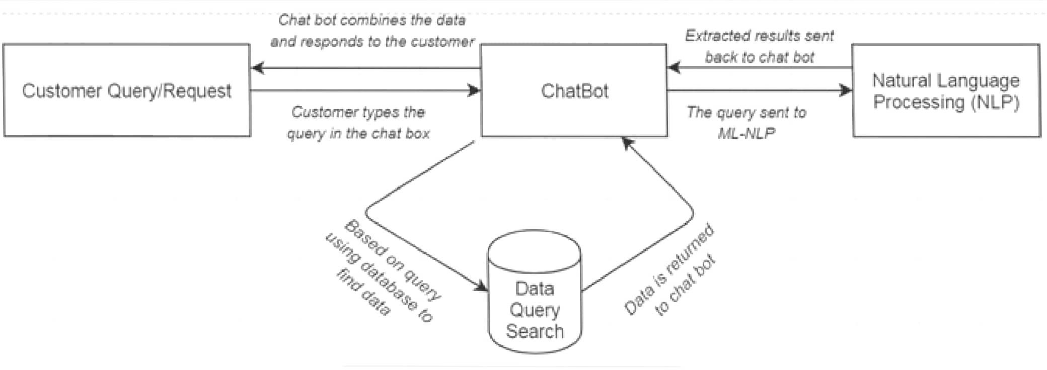

* Software Requirements: Windows OS , Visual Studio ,
* Html , CSS , Java Script for fronted.
* Python ML Algorithms-NLP for backend.
* SQL Database for storing the Queries.

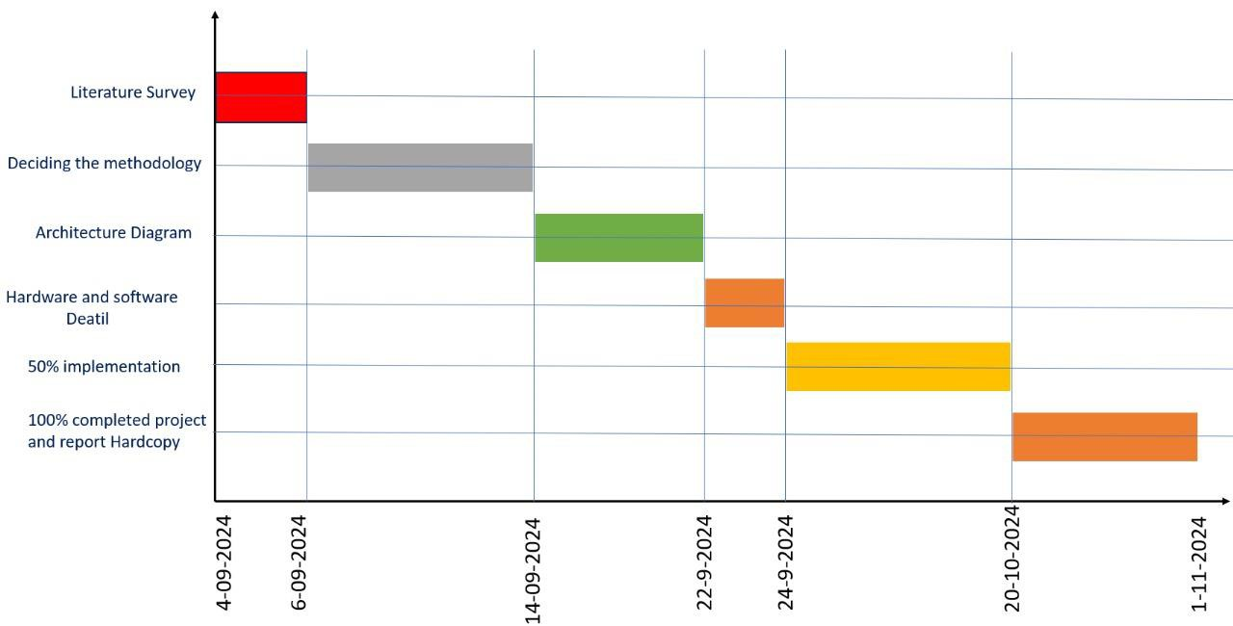

* Efficient Automation of Customer Service
* Text inputs will be used by the chatbot to respond to queries.Smooth User Interface Accurate
* Comprehension of user inquiries is ensured by Natural Language Processing (NLP).Customer satisfaction is increased by prompt responses and effective data retrieval . Feedback-Based Continuous Improvement
* By gathering user input, the chatbot will guarantee frequent updates and increased precision . As new data becomes available, machine learning models will change over time . Greater Accessibility
* For small and medium-sized businesses, the chatbot will be an affordable option . Using text, speech, input will boost user engagement for a variety of people.
* #include <stdio.h>
* #include <string.h>
* 1.Start
* Scroll through the items
* Add to cart
* Buy
* Step 2: Display the Homepage
* if(chatbot is activated)
* {



•

Read the user's input (query).

* launch chatbot;
* }
* Step 3: Handle User Input
* Ask the user for their choice
* Read the user's input (choice).
* Step 4: Chatbot Interaction
* 1.If the user selects Option 1:
* Launch the chatbot.
* Print: "Chatbot Launched.
* 2.Prompt the user to enter a question:
* Print: "Enter your question:"



•

Copy the query into db[db_size].question.

* 3.Initialize a variable found to 0 to track if the query exists in the database.
* Step 5: Query the Database
* 1.Search for the user's query in the database:
* Loop through the database (db) using a for loop.
* If a match is found (strcmp(db[i].question, query) == 0)
* Set found to 1.
* Display the chatbot's response (db[i].response).
* Break out of the loop.
* 2.If the query is not found (found == 0):
* Print: "Chatbot Response: Contact Administration."
* Add the unanswered query to the database:
* Set the response for this query as "Pending further investigation."
* Increment db_size to reflect the new entry.
* Print: "Unanswered query added to the database."
* step 6:Loop
* 1.If a match is found (strcmp(db[i].question, query) == 0):
* Set found to 1.
* Display the chatbot's response (db[i].response).
* Break out of the loop.
* 2.If the query is not found (found == 0):
* Print: "Chatbot Response: Contact Administration."
* Add the unanswered query to the database:



* step 9:Exit the loop
* Copy the query into db[db_size].question.
* Set the response for this query as "Pending further investigation."
* Increment db_size to reflect the new entry.
* Print: "Unanswered query added to the database."
* Step 7: Close Chatbot or Exit Program
* 1.If the user selects Option 2:
* Print: "Chatbot Closed. Exiting Program..."
* Set running to 0 to exit the loop.
* step 8: If the user provides an invalid input:
* Print: "Invalid Choice. Please try again."
* Print: "Server Shut Down."
* step 10: close the chatbot
* else{
* continue shopping;
* }
* END
* The contribution is the development of a customer support chatbot using machine learning (ML) and natural language processing (NLP) in Python. While there are various chatbots available—both rule-based and self-learning—many are underutilized in the customer service domain. Rule-based chatbots tend to be rigid and struggle to comprehend the nuances of customer inquiries, such as context or slang. In contrast, self-learning chatbots utilize ML and NLP to understand and respond to diverse queries more effectively. This adaptability not only allows for immediate access to information but also enhances user satisfaction by providing personalized interactions. Moreover, these chatbots can operate around the clock, reducing wait times and freeing human agents to tackle more complex issues

# Github Link

The Github link provided should have public access permission.

**Github Link:**

<https://github.com/navii354/CUSTOMER-SUPPORT-CHATBOT-WITH-ML>

* Customer Support Chatbot Using Machine Learning [https://www.researchgate.net/publication/343980800_Customer](https://www.researchgate.net/publication/343980800_Customer_Support_Chatbot_Using_Machine_Learning)

[_Support_Chatbot_Using_Machine_Learning](https://www.researchgate.net/publication/343980800_Customer_Support_Chatbot_Using_Machine_Learning)

* Yordanov, V.: Introduction to NLP for text. [https://towardsdatascience.com/introduction-to-natural- language-processing-for-text-df845750fb63](https://towardsdatascience.com/introduction-to-natural-language-processing-for-text-df845750fb63%0d)
* Customer Support Chatbot with ML Research paper [https://www.ijrte.org/wp- content/uploads/papers/v8i1S3/A10170681S319.pdf](https://www.ijrte.org/wp-content/uploads/papers/v8i1S3/A10170681S319.pdf)
* [Ollama https://www.analyticsvidhya.com/blog/2023/10/a-step- by-step-guide-to-pdf-chatbots-with-langchain-and-ollama/](https://www.analyticsvidhya.com/blog/2023/10/a-step-by-step-guide-to-pdf-chatbots-with-langchain-and-ollama/)

# Project work mapping with SDG

## The Project work carried out here is mapped to SDG-9

**industry,innovation and infrastructure:** A chatbot can enhance business operations and customer service efficiency

## through innovation.

Thank You